Project - High Level Design
on
Chat with Logistics Documents (RAG)

  - Course Name: Generative AI

Medicaps University – Datagami Skill Based Course

Student Name(s) & Enrolment Number(s):
Sr no | Student Name | Enrolment Number
1 | AKSHAT BAJAJ | EN22CS301088
2 | AKANKASHA PARIHAR | EN22CS301079
3 | AJAY PAL SINGH THAKUR | EN22CS301077
4 | AKSHITA FARKYA | EN22CS301099
5 | AASHITA CHAVHAN | EN22CS301018
6 | AAKRATI JAIN | EN22CS301013

Group Name: Group 05D1
Project Number: GAI-05
Industry Mentor Name: Aashruti Shah
University Mentor Name: Prof. Ajaj Khan
Academic Year: 2025-26

Table of Contents:
- Introduction.
  - Scope of the document.
  - Intended Audience
  - System overview.
- System Design.
  - Application Design
  - Process Flow.
  - Information Flow.
  - Components Design
  - Key Design Considerations

- Data Design.
  - Data Model
  - Data Access Mechanism
  - Data Retention Policies
  - Data Migration
- Interfaces
- State and Session Management
- Caching
- Non-Functional Requirements
  - Security Aspects
  - Performance Aspects
- References

1. Introduction
The Chat with Logistics Documents (RAG) project is a sophisticated intelligent logistics assistant engineered to mitigate the challenges of "information overload" typically associated with massive technical documentation. This system serves as a bridge between static, unstructured PDF data and dynamic, interactive intelligence by integrating the LangChain framework with the Google Gemini 2.0 Flash Large Language Model (LLM).
The core objective of this architecture is to provide a comprehensive technical and operational framework specifically optimized for the logistics and supply chain intelligence sector. By utilizing FAISS (Facebook AI Similarity Search) for high-speed semantic retrieval, the system ensures that AI-generated responses are not based on general training data, but are strictly grounded in the provided logistics datasets. This design spans the entire data lifecycle—from the initial ingestion and structural parsing of binary PDF data using PyPDFLoader to the generation of contextually accurate, human-like reasoning.
The system addresses the critical need for rapid data extraction regarding shipment statuses, inventory levels, and environmental monitoring, transforming standard logistics manuals into a high-performance, machine-readable knowledge base.

1.1 Scope of the Document
This document defines the comprehensive technical architecture and operational framework for a Retrieval-Augmented Generation (RAG) system, specifically optimized for the logistics and supply chain intelligence sector. The scope of this design encompasses the entire data lifecycle—from the ingestion of raw, unstructured professional reports to the generation of contextually grounded, human-like responses.
- PDF Ingestion & Structural Parsing: It defines the use of PyPDFLoader to deserialize binary PDF data from logistics manuals into machine-readable text formats.
- Semantic Vectorization: It outlines the implementation of transformer-based embedding techniques using the all-MiniLM-L6-v2 model to map textual data into a 384-dimensional vector space.
- LLM-Based Reasoning: It orchestrates the Google Gemini 2.0 Flash model to perform logical reasoning over retrieved document chunks, ensuring every generated answer is strictly "grounded" in the uploaded logistics data.

1.2 Intended Audience
- Internal Stakeholders: Group members (Ajay, Akshat, Akshita, Aashita, Akanksha, Aakrati) responsible for technical implementation.
- Academic Reviewers: Faculty members at Medicaps University evaluating design modularity.
- Domain Users: Logistics operators requiring rapid extraction of specific data points from technical manuals.

1.3 System Overview
The system is engineered as an intelligent logistics assistant specifically designed to mitigate the problem of "information overload" prevalent in technical documentation. By integrating the LangChain framework with Google Gemini 2.0 Flash, the system converts static, unstructured PDF data into a dynamic and interactive knowledge base.
The architecture leverages FAISS (Facebook AI Similarity Search) to perform high-speed semantic retrieval, ensuring that the AI’s responses are derived exclusively from the provided logistics datasets. This RAG (Retrieval-Augmented Generation) approach allows for the automated extraction of critical logistics variables with high factual accuracy and low latency.

2. System Design
The system design for the GAI-05: Chat with Logistics Documents project follows a modular, scalable architecture specifically engineered for high-performance retrieval and low-latency generation. Below is an exhaustive elaboration of each sub-section within the design phase.

2.1 Application Design
The application is structured into four logical tiers to ensure a clean separation of concerns and modularity:
- Presentation Layer (Frontend): Developed using Streamlit, this layer provides the end-user interface. It handles user authentication via API keys, accepts natural language queries, and renders AI responses in real-time.
- Orchestration Layer (Middleware): Powered by LangChain, this layer acts as the "glue" that connects data loaders, text splitters, vector stores, and the LLM. It manages the state of the document processing pipeline.

- Intelligence Layer (Backend): This tier utilizes the Google Gemini 2.0 Flash model to perform semantic reasoning. It processes the augmented prompt (context + query) to generate a response grounded in the logistics dataset.
- Persistence Layer (Vector DB): A FAISS (Facebook AI Similarity Search) index serves as the in-memory vector database, storing high-dimensional embeddings for rapid retrieval.

2.2 Process Flow
The process flow describes the sequential lifecycle of a document from its raw state to an indexed searchable format:
- Document Ingestion: The PyPDFLoader module reads the binary data of the logisticspdf.pdf file and converts it into a list of document objects containing raw text and page-level metadata.
- Recursive Chunking: To handle LLM context window limits, the RecursiveCharacterTextSplitter segments the text into 1,000-character chunks. A 200-character overlap is maintained between chunks to ensure that semantic meaning across sentence boundaries is not lost.
- Vector Transformation: Each text chunk is passed through the all-MiniLM-L6-v2 transformer model, which outputs a 384-dimensional numerical vector representing its semantic essence.
- Indexing: These vectors are then inserted into the FAISS index, creating a searchable mathematical map of the entire logistics document.

2.3 Information Flow
The information flow details the dynamic path taken by a user query to fetch a response:
- Query Vectorization: The user's question (e.g., "Check status of shipment") is converted into a vector using the same HuggingFace embedding model used during ingestion.
- Semantic Retrieval: The system calculates the mathematical distance (L2 or Cosine) between the query vector and the document vectors in FAISS, retrieving the top 2 (k=2) most similar chunks.
- Contextual Augmentation: The retrieved chunks are formatted as a "context" block and appended to a system prompt that enforces strict grounding.
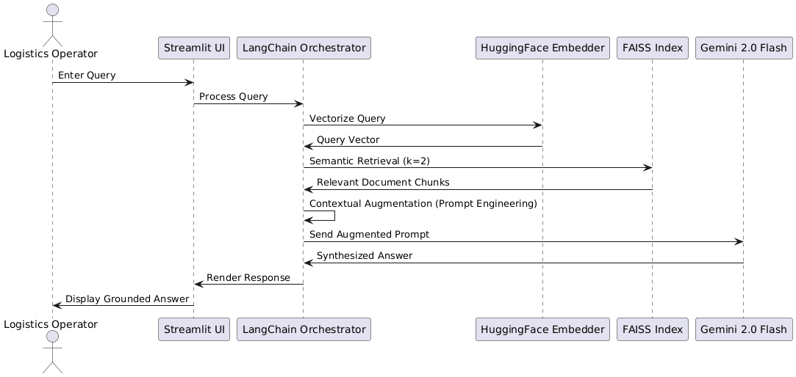

2.4 Components Design
- The Retriever (FAISS): Chosen for its efficiency on CPU architectures, allowing for sub-millisecond similarity searches without requiring expensive GPU hardware.
- The Generator (Gemini 2.0 Flash): A lightweight yet highly capable LLM configured with a Temperature of 0.3 to favor deterministic, factual answers over creative ones.
- The Embedder (HuggingFace): Uses the all-MiniLM-L6-v2 model, which is optimized for both speed and semantic accuracy in logistics domain language.

2.5 Key Design Considerations
- Anti-Hallucination Guardrails: The system prompt includes a "fail-safe" instruction: if the retrieved context does not contain the answer, the model must respond with "Answer not found in the document".
- Efficiency via Caching: Using Streamlit’s @st.cache_resource decorator, the vector store is cached in memory, ensuring that the PDF is only processed once per application start, significantly improving user experience.
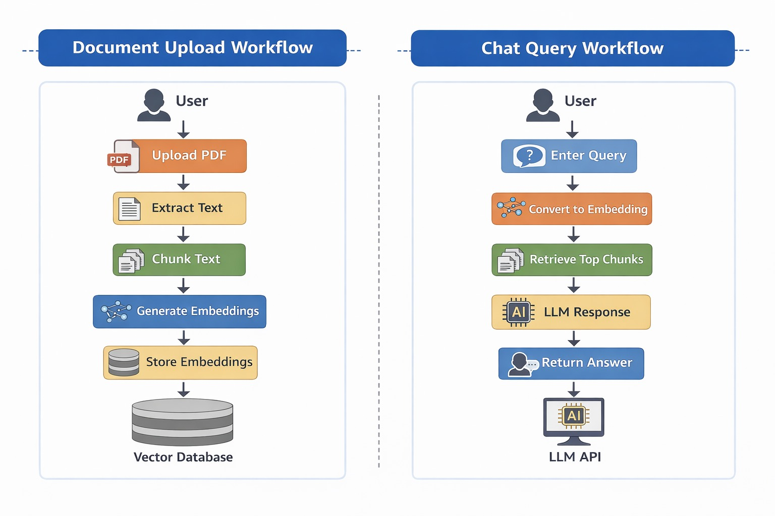

3. Data Design
The Data Design section focuses on how information is structured, stored, and accessed within the GAI-05: Chat with Logistics Documents (RAG) system. It outlines the transition from unstructured PDF text to high-dimensional mathematical representations.

3.1 Data Model
The system operates on a hybrid data model that manages both human-readable text and machine-optimized numerical vectors:
- Unstructured Source Data: The primary input consists of professional logistics documents (e.g., logisticspdf.pdf) containing semi-structured fields such as Shipment_Status, Inventory_Level, Temperature, and Logistics_Delay_Reason.
- Document Objects: After ingestion, data is held in LangChain Document objects. Each object contains:
  - Page Content: The actual string of text from the logistics manual.

  - Metadata Schema: Key-value pairs including the file source path, total page count, and specific page labels to ensure traceability of the generated answers.
- Vector Embeddings: The core data representation is a 384-dimensional dense vector generated by the all-MiniLM-L6-v2 model. This numerical schema allows the system to perform mathematical operations on linguistic meaning.

3.2 Data Access Mechanism
Unlike traditional SQL databases that rely on exact keyword matches, this system utilizes a Semantic Retrieval Mechanism:
- Indexing Strategy: The system uses the FAISS (Facebook AI Similarity Search) index to organize vectors.
- Similarity Search Logic: When a user query is received, it is vectorized and compared against the stored chunks using L2 Distance (Euclidean Distance) or Cosine Similarity.
- Retrieval Parameters: The system is configured for Top-K Retrieval (k=2), meaning only the two most mathematically relevant document segments are pulled to serve as context for the Gemini LLM.

3.3 Data Retention Policies
Given that this is a real-time retrieval system running in a cloud/local environment (Colab/Streamlit), the following policies apply:
- In-Memory Storage: The FAISS index and the loaded documents are stored in the application's RAM during the active session.
- Session-Based Caching: Using @st.cache_resource, the data is retained across UI refreshes to avoid the overhead of re-parsing the PDF, but it is cleared when the Streamlit server process is terminated.
- Zero Persistent Footprint: In its current configuration, the vector store is not saved to a permanent disk (e.g., a .faiss file), ensuring high data privacy as no permanent copies of the embedded data remain after the session ends.

3.4 Data Migration
The data ingestion pipeline is designed for "On-the-Fly" migration of PDF content to the vector store:
- Automated Pipeline: The system automatically handles the migration from file upload to vectorization using the load_and_process_pdf() function.

- Chunk Continuity: By using a 200-character overlap during the data splitting phase, the system ensures that information that might span across two pages or paragraphs remains retrievable in its full context.
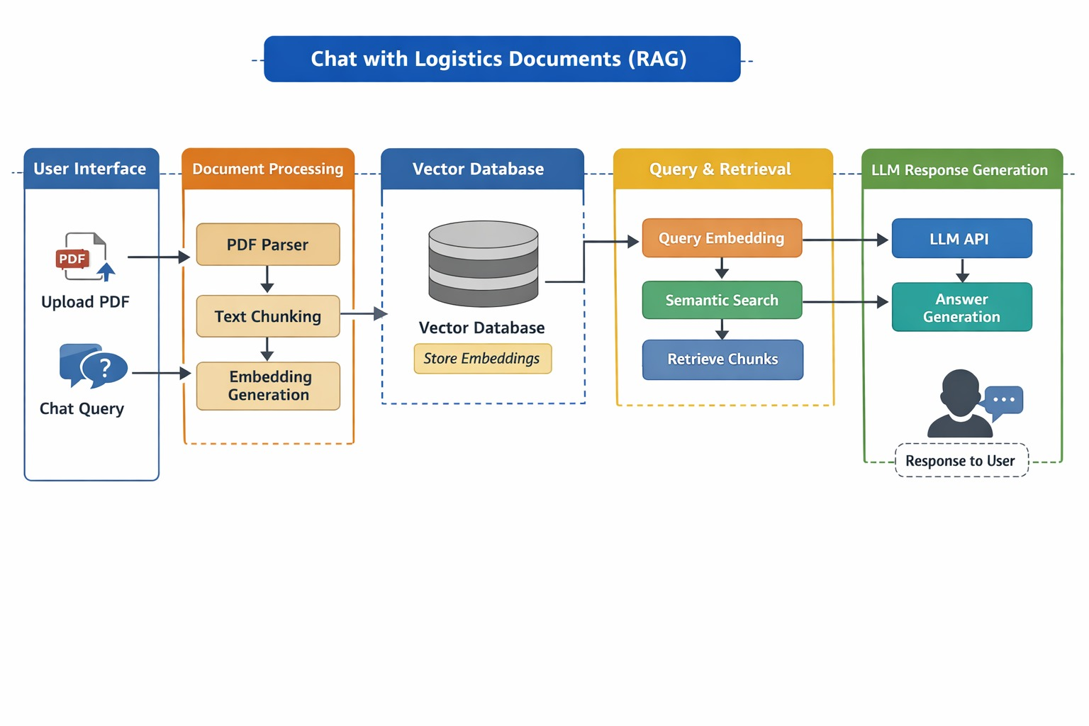

4. Interfaces
The Interfaces section establishes the communication protocols between human operators, the automated RAG pipeline, and external cloud services. It defines the specific touchpoints where natural language queries are transformed into actionable logistics intelligence by bridging the gap between user input and the internal data structures of the system.
This architecture utilizes a web-based front-end for accessibility, a suite of external APIs for intelligence and secure networking, and internal ingestion interfaces to handle the conversion of static PDF documents into active system memory. Together, these interfaces ensure a seamless flow of information, providing real-time feedback and secure remote access for logistics data analysis

5. State and Session Management
The State and Session Management section describes how the system maintains continuity during a user’s interaction and manages data persistence across the application’s lifecycle.

This layer ensures that the heavy computational resources required for the RAG pipeline are handled efficiently while providing a stable connection for remote users.
The system utilizes Streamlit’s session state to track query history and pyngrok to maintain stable external connectivity. To optimize performance, the system employs resource caching
via decorators, ensuring that the PDF loading and vector store creation occur only once during the application's initialization. While the intelligence layer itself remains stateless, continuity is maintained by the retriever, which pulls the most relevant "state" from the document for every new query. Upon system termination, all in-memory states and cached resources are flushed to ensure no residual logistics data remains on the host machine.

6. Caching
This section outlines the optimization strategies used to reduce computational redundancy and improve the overall response latency of the GAI-05: Chat with Logistics Documents system. The architecture implements a multi-layered caching approach to handle expensive I/O operations and memory-intensive model loading efficiently.
The core of the strategy relies on computational caching using specialized decorators to ensure that the document ingestion pipeline—including PDF parsing, text chunking, and embedding generation—is executed only once per application start. This is complemented by model weight caching, where local libraries retain transformer and LLM weights to avoid repeated high-bandwidth downloads. By maintaining the FAISS vector store in the system's
RAM, the system achieves near-zero latency during similarity searches while ensuring thread-safe access for multiple concurrent users. To maintain data privacy and integrity, all cached resources are volatile and are automatically purged upon system termination, with a manual reset required only if the underlying source document is updated.

7. Non-Functional Requirements
This section defines the operational standards and quality attributes that ensure the GAI-05: Chat with Logistics Documents (RAG) system is secure, reliable, and efficient.

7.1 Security Aspects
- Credential Protection: The system strictly avoids hardcoding sensitive credentials. The GOOGLE_API_KEY is managed via os.environ, ensuring that API keys are injected at runtime and never exposed in the source code or version control.
- Encrypted Communication: By utilizing pyngrok, all external traffic to the Streamlit application is routed through a secure HTTPS tunnel. This provides end-to-

end TLS encryption, protecting logistics data from interception during remote access.
- Data Privacy: The FAISS vector store is designed to be volatile and in-memory. No permanent copy of the embedded document data is stored on the local disk, meaning that once the session is terminated, all sensitive logistics information is automatically purged.

7.2 Performance Aspects
- Low Latency Retrieval: The choice of the all-MiniLM-L6-v2 model is a key performance driver. It is a lightweight transformer that allows the system to perform complex semantic searches in sub-second timeframes without requiring high-end GPU resources.
- Optimized LLM Inference: Using the Gemini 2.0 Flash model provides a high-speed generation phase. Its "Flash" architecture is specifically optimized for low-latency tasks, ensuring that the time-to-first-token is minimized for a better user experience.
- Resource Efficiency: The system utilizes FAISS-CPU, which is highly optimized for multi-core processors. This allows the application to handle the chunking .

7.3 Reliability and Availability
- Graceful Error Handling: The application includes try-except blocks in the document loading and query functions to prevent system crashes. If a PDF fails to load, a clear st.error message is displayed to the user.
- System Grounding: The strict prompt engineering (setting the temperature to 0.3 and adding fallback instructions) ensures that the system provides reliable, factual answers rather than inconsistent or creative hallucinations.

8. References
- LangChain Documentation: Reference for orchestrating the RAG pipeline.
- Google Gemini API Reference: Documentation for model parameter management.
- FAISS Library: Reference for efficient vector search implementations.
- Streamlit Framework: Official guide for building interactive web interfaces

